Provisioning Fabric Trial Tenant

Value Based Delivery resources

May 2024

Contents

1. Document Purpose 3

2. IMPORTANT UPDATE 4

3. Recorded Demo for Trial Tenant Creation 7

4. Technical Design 8

5. Limitation with Fabric deployment per region 10

6. Optimizing Microsoft Fabric Trial Capacities distribution 11

7. Global Email Account Creation 13

8. Create the Microsoft 365 E5 Trial Tenant 14

9. Prepare M365 users 18

10. Create M365 users 19

11. Configure the Fabric Tenant 21

12. Enable Fabric Trial capacity for the tenant administrator 23

13. Enable Fabric Trial capacities for the first 4 users 24

14. Reset the password for the first 4 users 25

15. Provision and Configure Fabric Workspaces 27

16. Sharing credentials to workshop users 30

17. Activating Users environment 31

1. Document Purpose

Value Based Delivery (VDB) engagement related to Microsoft Fabric can require Trial Tenant for customer readiness especially for “Upskilling Execution” deliveries.

Creating Trial Tenant allows bypassing security and governance applicable to the customer environment. The procedure described in this document should be executed before the delivery to offer the best experience to the workshop attendees.

**IMPORTANT:**

This March 2024 document version includes two assets located in the folder **Fabric Trial Tenant Assets**:

* FabricWorkspaceSetUp.ps1
* Import_User.csv

Please download these 2 assets before starting the tenant setup.

1. IMPORTANT UPDATE

The alias [https://aka.ms/testM365E5](https://nam06.safelinks.protection.outlook.com/?url=https%3A%2F%2Faka.ms%2FtestM365E5&data=05%7C02%7CMathias.Ekizian%40microsoft.com%7Cd789b806282c4ddcfd0208dc5fb4d030%7C72f988bf86f141af91ab2d7cd011db47%7C1%7C0%7C638490477424677121%7CUnknown%7CTWFpbGZsb3d8eyJWIjoiMC4wLjAwMDAiLCJQIjoiV2luMzIiLCJBTiI6Ik1haWwiLCJXVCI6Mn0%3D%7C0%7C%7C%7C&sdata=VhN%2F%2BzQkCIxW4Qnr63Am5z8QyIFGInh28A3mIjZNyUE%3D&reserved=0) returns an error since the 14th of April.

This has been escalated to the Product Group, who has temporarily disabled this trial tenant creation mechanism, with no ETA to get it available again.

Possible workarounds are:

1 - Use the URL provided in this [article](https://learn.microsoft.com/power-bi/enterprise/service-admin-signing-up-for-power-bi-with-a-new-office-365-trial) to create the tenant  - it comes from this official Fabric blog [article](https://blog.fabric.microsoft.com/en-us/blog/accessing-microsoft-fabric-for-developers-startups-and-enterprises?ft=All).

This is like the alias mentioned previously, however as written in the blog post: *“This process will require providing a payment method and will enable recurring billing after 30 days (which can be disabled with additional steps).  This will be mentioned during the registration process”*

**If you use this option, make sure you will disable the billing option as you are directly responsible for the tenant management and associated costs if not used properly.**

To disable the billing option, go the Microsoft 365 Admin Center and select **Your products** in the Billing menu category.

Select the **Office 365 product** and choose **Edit recurring billing** in the contextual menu.

On the **Edit recurring billing** popup, Select **Off** to let this subscription 30 days after its creation.

Go to the Microsoft 365 Product and ensure that the Recurring billing is turned Off.

When the upskilling session is completed and you want to cancel the M365 subscription, select the production in the Your products section, and click on **Cancel subscription**.

2 - Use the [CDX](https://cdx.transform.microsoft.com/my-tenants) platform to create the demo M365 demo environment, then apply the remaining part of the Fabric setup. As users are automatically created you will have to delete them and create Lab Users as documented.

Accessing to CDX can require up to 5 days, so you should ask for the access in advance.

3 - Use the trial tenant in the [Developer Program](https://developer.microsoft.com/en-us/microsoft-365/dev-program) – main drawback is that only a single trial tenant can be created per registered account

1. Recorded Demo for Trial Tenant Creation

The fully recorded demo is available: <https://aka.ms/FabricVBDTrialTenant>

Note: this demo does not include the recurring billing disablement, so please make sure you will turn it off as mentioned in the previous section.

1. Technical Design

As the [CDX](https://cdx.transform.microsoft.com/) platform is not designed to support Customer Training activities, this environment is not mentioned in this document.

The procedure described hereafter is based on the Microsoft Developer program which allows us to create an M365 Trial Tenant with 25 E5 licenses (which represents the maximum number of users you can simultaneously host at the same time during the workshop).

As the lifetime of the trial tenant is limited to 30 days, the tenant should not be configured too much in advance before the workshop (5 to 10 days before the workshop is a good choice).

As only 5 Fabric Trial capacities can be enabled per tenant, the technical strategy is the following:

1. Create a new dedicated email address.
2. Create the Microsoft 365 E5 Trial Tenant
3. Create user accounts and assign E5 Licenses
4. Configure the Fabric Tenant
5. Enable the 5 Trial capacities (Admin + 4 first lab users)
6. Provision Fabric Workspaces, assign users and trial capacities
7. Share credentials to workshop users

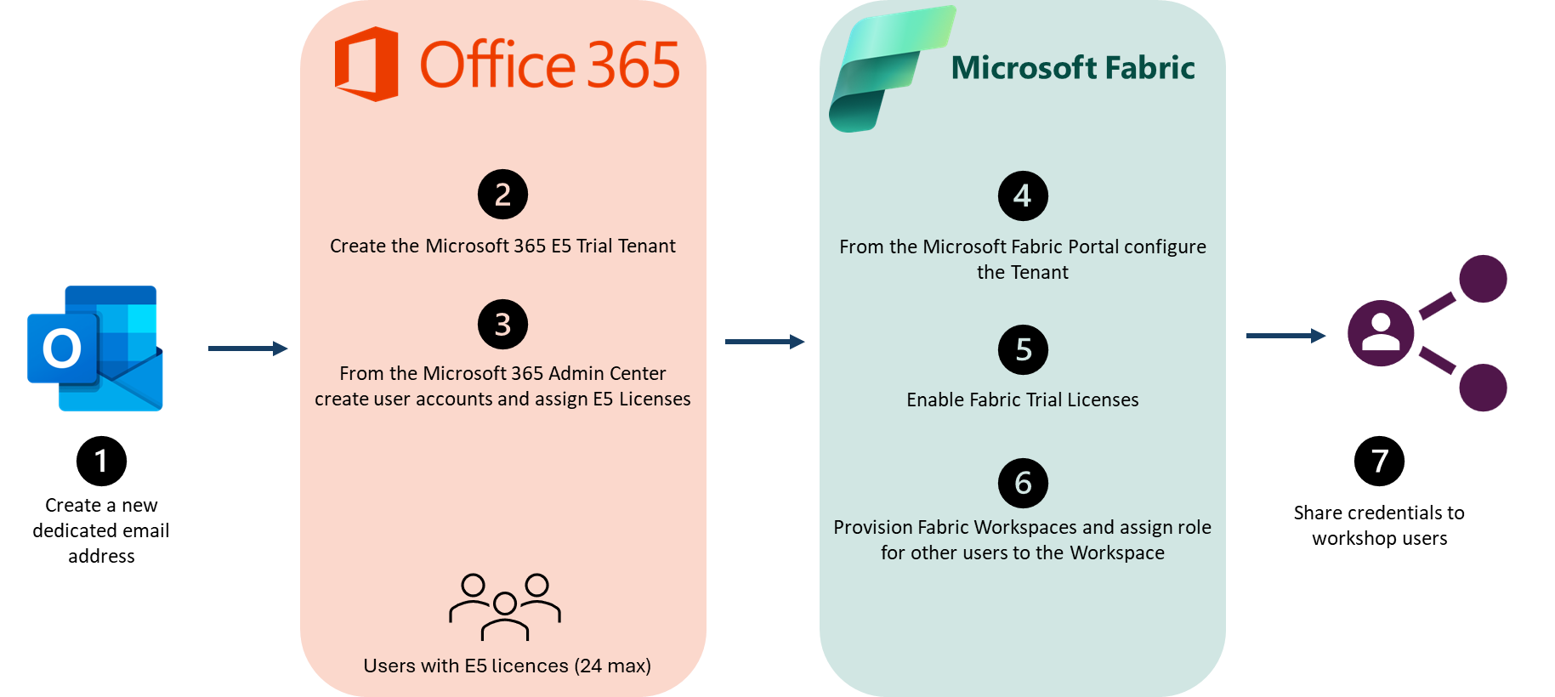

It is also possible to use a Microsoft 365 developer sandbox subscription, which allows to keep the tenant for 90 days.

However, this program has some specific limitations, in particular the fact that the same phone number cannot be used multiple times to confirm the identity of the subscription creator.

1. Limitation with Fabric deployment per region

Microsoft Fabric is available in the following region (January 2024):

|  |  |  |  |
| --- | --- | --- | --- |
| Europe | Americas | Asia Pacific | Middle East and Africa |
| NorthEurope  WestEurope  FranceCentral  GermanyWestCentral  NorwayEast  SwedenCentral  SwitzerlandNorth  SwitzerlandWest  UKSouth  UKWest | BrazilSouth  CanadaCentral  CanadaEast  EastUS  EastUS2  NorthCentralUS  SouthCentralUS  WestUS  WestUS2  WestUS3 | AustraliaEast  AustraliaSoutheast  CentralIndia  EastAsia  JapanEast  KoreaCentral  SoutheastAsia  SouthIndia | SouthAfricaNorth  UAENorth |

[Fabric region availability - Microsoft Fabric | Microsoft Learn](https://learn.microsoft.com/en-us/fabric/admin/region-availability)

|  |
| --- |
| **IMPORTANT** |
| When creating your tenant for your VBD delivery, you should make sure [the tenant home region](https://learn.microsoft.com/en-us/fabric/admin/find-fabric-home-region) will have Microsoft Fabric available, otherwise, you won’t be able to create Fabric Trial capacities and use Fabric workloads such as Lakehouse, Data Engineering or Real Time Analytics.  If you are physically located in a region where Microsoft Fabric is not available, the best workaround is to ask to a colleague, based on a region where Microsoft Fabric is available to execute the first step for the M365 E5 Trial tenant creation (section 5 in the document).  Once the M365 tenant is created, you should be able to execute the next steps and use the Fabric Trial Capacities. |

1. Optimizing Microsoft Fabric Trial Capacities distribution

First, it is important to understand the difference between:

* **M365 E5** Trial Licenses
* **Microsoft Fabric** Trial Capacities

When creating a M365 E5 Trial Tenant, you will benefit from 25 M365 E5 licenses you will assign to your users. The individual M365 E5 Licence includes [Power BI Pro](https://powerbi.microsoft.com/en-us/pricing/) to enable collaborative features (publishing content) within collaborative workspaces.

It is also possible to create [Microsoft Fabric Trial Capacities](https://learn.microsoft.com/en-us/fabric/get-started/fabric-trial) (January 2024 : 5 Fabric Trial capacities per tenant).

As mentioned in the documentation, each user asking for Fabric in Trial mode, becomes the admin of a specific Fabric capacity in trial mode. Users having the Fabric administrator role can see all Fabric Trial capacities.

That means that only users having this specific assignment (Fabric Trial Capacity) will be able to promote a workspace as a Fabric workspace, and then their capacity will support the workspace workload.

Nevertheless, the other users can contribute to these Fabric workspaces as far as they have a M365 E5 or Power BI Pro License.

When all Fabric workspaces are created by the global administrator (CSA), all these workspaces will be assigned to the same Fabric capacity trial capacity, which can lead to performance issue, because of scalability issue, based on a single capacity, which is not limitless.

Therefore, in the case of delivering a Fabric workshop with more than 10 users, it is strongly recommended to spread all workspaces across multiple capacities:

The benefit of this design is to distribute all provisioned workspaces between the 5 capacities.

To achieve this scenario, for each workspace:

* Keep the workspace as a Power BI Pro workspace, and add the administrator of the Fabric capacity you are targeting as a workspace administrator
* Ask to this user to promote the workspace as a workspace in Trial – the workspace should be automatically mapped to the capacity owned by this user.

**This March 2024 document version includes a Power Shell script which will automatically:**

* **Create the 24 workspaces (one per user)**
* **Spread these 24 workspaces between the 5 capacities.**

1. Global Email Account Creation

Creating an M365 Trial Tenant using the Developer Program requires work or school email address.

⚠️The email address can be used to only create one tenant, so it is required to create a dedicated email address before each new tenant creation.

Create a new email [Outlook](https://outlook.live.com/) email address.

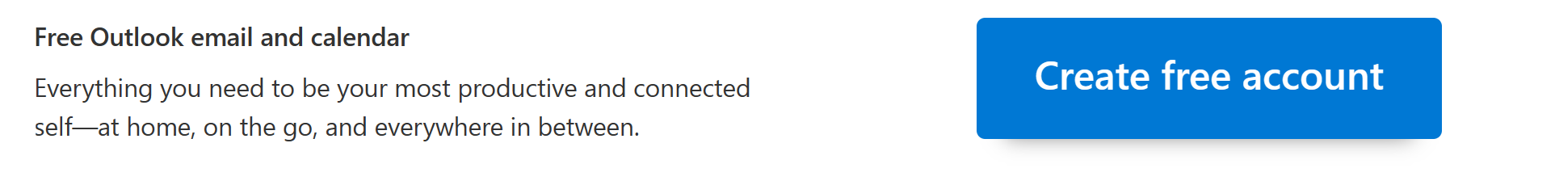

Type the new email address.

Make sure the inbox is accessible.

1. Create the Microsoft 365 E5 Trial Tenant

Use the following link to create the new tenant: <https://aka.ms/testM365E5>

Type the email address created in the previous step.

Validate the select email address and set up the account.

Fill-up the form to complete the creation.

Configure the account will be Global Administrator (this account will be used to execute most of the administrative tasks before opening the tenant to the workshop attendees).

For simplicity, we recommend using the login name “admin”.

Sign in using the previously created email address.

Confirm the Tenant creation to proceed.

NOTE: in this example the tenant name is **fabricvbdupskilling.onmicrosoft.com**

This is an important parameter to be used when configuring some assets during the next steps.

Click on **Continue** to enable Microsoft 365 applications.

Select the proposed domain name and click on **Use this domain**.

**DO NOT create user with the wizard, they will be created later.**

Click on **Go to the admin center**.

1. Prepare M365 users

Download and edit the file **Import_Users.csv** located in the **Fabric Trial Tenant Assets** folder located in the [**Fabric main folder**](https://microsoft.sharepoint.com/:f:/r/teams/ASDIPRelease/IP%20Release/Data%20and%20AI/Fabric?csf=1&web=1&e=rOKZMV).

The mask <your_tenant> must be replaced with your tenant.

Save the file when the replacement is completed.

1. Create M365 users

Go to the [Microsoft 365 Admin Center](https://admin.microsoft.com/AdminPortal) and go to the **Active users** layout.

Use the **Add multiple users,** enable the **checkbox** highlighted in yellow and click on **Browse** to select the CSV file **Import_Users.csv**

Click on **Next** when the validation process is completed.

Assign a M365 E5 license for each created user (no remaining licenses will be available after).

Complete the user creation process.

Click on **Download user details** to obtain temporary user password.

1. Configure the Fabric Tenant

Go to the [Power BI portal](https://app.powerbi.com/) and click on the gear icon and select **Admin Portal**.

On the Admin Portal, go to the **Tenant-setting** panel. Ensure **Enabled** is selected for **the Users can Create Fabric items**.

Ensure **Enabled** is selected for **the Users can try Microsoft paid features**.

1. Enable Fabric Trial capacity for the tenant administrator

Go to the user profile from the Top Right corner and click on **Start trial** to enable the **Fabric Trial license** for the current user.

Confirm the upgrade.

The Trial status should be available for the current user.

NOTE: Enabling the Fabric Trial for the tenant administrator will provision 1 of the 5 Fabric Trial capacities.

1. Enable Fabric Trial capacities for the first 4 users

The following operation must be done manually for the first 4 users created in bulk mode using the CSV file (only the ones selected) :

For each user:

* Open your browser in private mode and go to app.powerbi.com
* Type the user email address (ex : [user01@fabricvbdupskilling.onmicrosoft.com](mailto:user01@fabricvbdupskilling.onmicrosoft.com)) and click on submit
* Type the password written in the file and then type a new password (you will reset it later)
* Go to the user profile from the Top Right corner and click on **Start trial** to enable the **Fabric Trial license** for the current user.
* Confirm the upgrade.
* Close the browser

Reconnect to PowerBI using your admin account and go to the Admin Portal > Capacity Settings.

The 5 capacities should appear in the **Trial** section.

1. Reset the password for the first 4 users

Go to the [M365 Admin Center](https://admin.microsoft.com/Adminportal/Home#/homepage) using the admin account, and go to Users > Active Users

Select the 4 first users and click on **Reset password**.

Confirm the operation.

Keep the new passwords and ideally update the CSV containing all the temporary (as these passwords will be distributed to the lab users.

1. Provision and Configure Fabric Workspaces

Download the Power script file **FabricWorkspacesSetUp.ps1** located in the **Fabric Trial Tenant Assets** folder located in the [**Fabric main folder**](https://microsoft.sharepoint.com/:f:/r/teams/ASDIPRelease/IP%20Release/Data%20and%20AI/Fabric?csf=1&web=1&e=rOKZMV).

Open the file with PowerShell ISE and update the line 61 to indicate the tenant name.

Change the tenant admin if requiered (should be “admin” as recommended in the procedure).

Save the script and execute it.

Use the tenant admin account for the connection.

The script will create the 24 workspaces and assigned to the Fabric Trial Capacities.

It should take ~3mn to be fully executed.

When completed, close PowerShell and go to the Fabric Portal using your admin account.

The 24 lab workspaces should appear.

In the admin portal, check that the 24 workspaces are distributed between the 5 capacities.

1. Sharing credentials to workshop users

Share to each workshop attendees the respective information.

Ex:

* User account: [user01@fabricvbdupskilling.onmicrosoft.com](mailto:user01@fabricvbdupskilling.onmicrosoft.com)
* Temporary password: Yaq89315
* Fabric workspace: LabUser01
* Each workspace user should have their own Fabric environment ready to use.

1. Activating Users environment

Each user should connect with their account and access the following resources:

* <https://www.office.com/>

Go to the OneDrive app to make sure it will activate for the Labs

* <https://app.powerbi.com/>

Make sure the user can see the assigned workspace.

